Matplotlib MCQ2

1.



2. which function can be used to export generated graph in matplotlib to png

(a) savefigure

(b) savefig

(c) save

(d) export

3.which function of matplotlib can be used to create a line chart?

(a)line

(b)plot

(c)graph

(d)bar

4.



5.

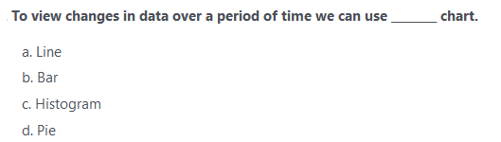

6.



7.

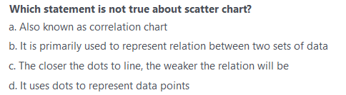

8.

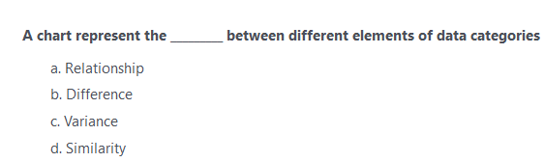

9.



10.

